**Background**

With the upgrade from classic Cloud Services to Cloud Services Extended Support the Azure Deployment task in Azure DevOps which was previously used to deploy your cloud service to a classic Cloud Service instance cannot be used to deploy your cloud service to a Cloud Services Extended Support instance. To address this issue we can leverage the new Update-AzCloudService PowerShell command to deploy our cloud service to a Cloud Services Extended Support instance.

**Azure DevOps Classic Build Pipeline**

For customers using the classic pipeline editor in Azure DevOps start by creating a build pipeline from the Azure Cloud Services build template.

Next, remove the Unit Test and Azure Deployment steps (**note:** you can keep the Unit Test steps if you have unit tests to execute against your Cloud Service)

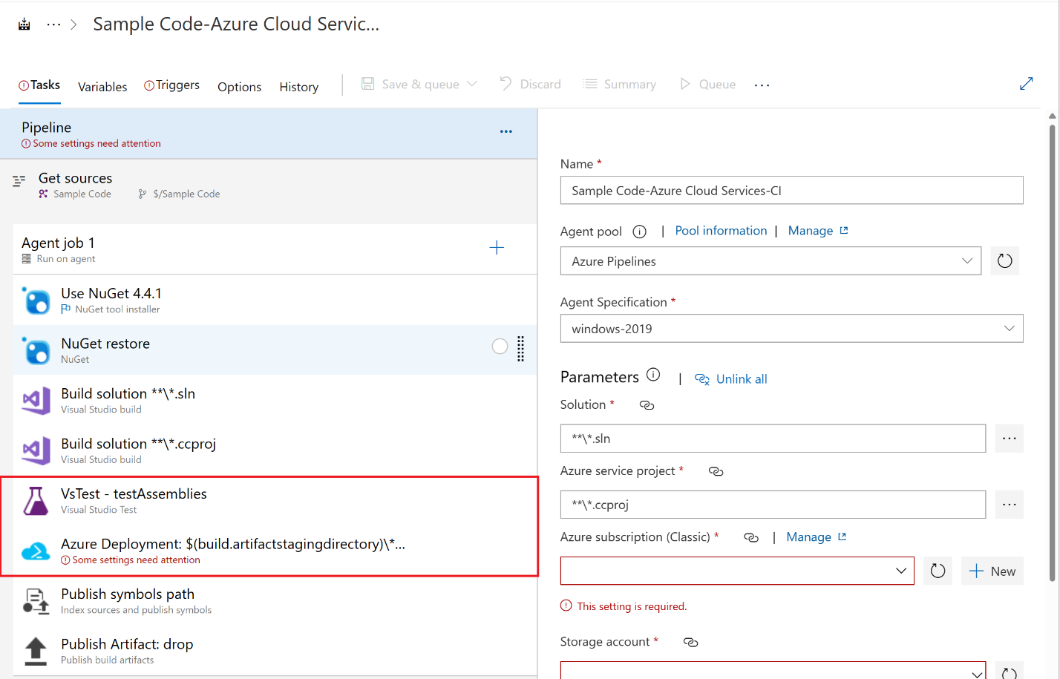

The final Build pipeline looks like this

**Azure DevOps Classic Release Pipeline**

For customers using the classic pipeline editor in Azure DevOps start by creating a release pipeline with the empty job release template.

Set the artifact on the release pipeline to the artifact published by your build pipeline.

Add an Azure file copy task and an Azure PowerShell task to the pipeline

The file copy task will copy the .cspkg file produced by the build pipeline to a container on an Azure Blob Storage account. It will output the storage container URI and the storage container SAS token for use by the PowerShell script. Make sure that the service principal associated with your Azure DevOps Service Connection has the Storage Blob Data Contributor RBAC role assigned to it on the storage account and you are using at least version 4.x of the Azure File Copy task or you will receive errors during the upload.

The Azure PowerShell task will do the following:

1. Construct the URL of the .cspkg file that was uploaded to Azure Blob Storage
2. Copy the contents of .cscfg file into a text variable
3. Retrieve the existing cloud services extended support definition
4. Set the Configuration property on the cloud service to the contents of the new .cscfg file
5. Set the PackageUrl property on the cloud service to the URL of the .cspkg file that was uploaded to Azure Blob Storage
6. Call the Update-AzCloudService command to update the cloud service

The full contents of the inline script contained in the Azure PowerShell task are shown below.

*$cspkgUrl = '$(BC.StorageContainerUri)CloudServiceToDeploy.cspkg$(BC.StorageContainerSasToken)'*

*# Retrieve the contents of the configuration file*

*$configuration = Get-Content -Path '$(System.DefaultWorkingDirectory)/_Cloud Services Extended Support Build/drop/ServiceConfiguration.Cloud.cscfg' | Out-String*

*# Retrieve the cloud service definition*

*$cloudService = Get-AzCloudService -ResourceGroupName "nimccfta-cloudservice-extended-rg" -CloudServiceName "nimccfta-cloudservice-extended"*

*# Update the cloud service*

*$cloudService.Configuration = $configuration*

*$cloudService.PackageUrl = $cspkgUrl*

*$cloudService | Update-AzCloudService*

If you want to run the PowerShell script directly from a PowerShell prompt, a stand-alone version of the PowerShell script can be found here [nimccoll/CloudServicesExtendedSupportDeployment: Demonstrates how to use PowerShell to deploy updates to an Azure Cloud Services Extended Support instance (github.com)](https://github.com/nimccoll/CloudServicesExtendedSupportDeployment).